*Asunder – How to Play*

**The Premise**

Enter the mind of a person torn asunder by guilt and self-doubts. Relive painful events of your past and work through the memories to reassemble your fragmented self. Find your missing body parts and combine their unique abilities to progress!

**The Goal**

* Collect all lost body parts
* Find a way to leave the protagonist’s mind

**The Controls**

In *Asunder*, you can play with mouse and keyboard or using a gamepad. At any time in the game, you can switch back and forth between the supported devices.

Gamepad controls

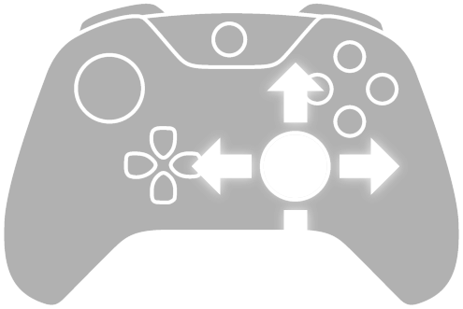

Keyboard and mouse controls

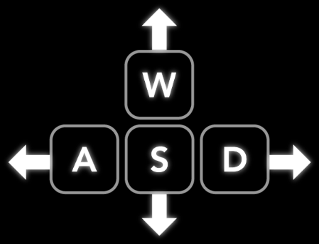

**The Abilities**

Each body part you find unlocks a new ability for you to use.

Use the legs to run up certain walls in the level. Do not stop! If you are not fast enough, you will not make it to the top of the wall. 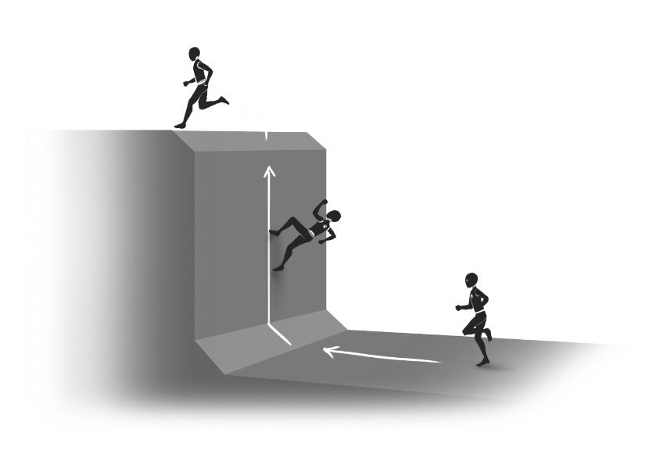

Unleash a powerful breath of wind using the torso. You can push and displace movable objects within a certain range.

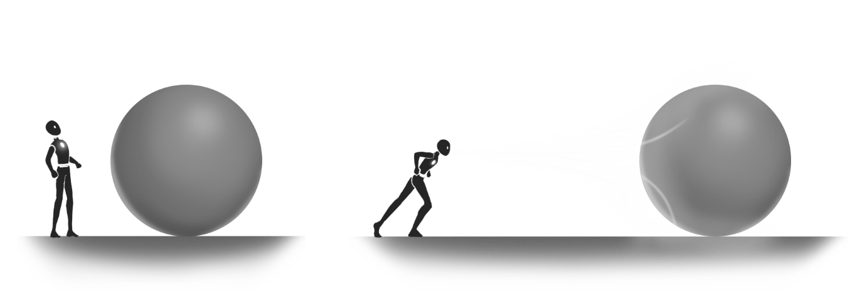

The arms grant you access to a hook shot. Aim at a solid surface nearby and fire the hook to reach that surface.

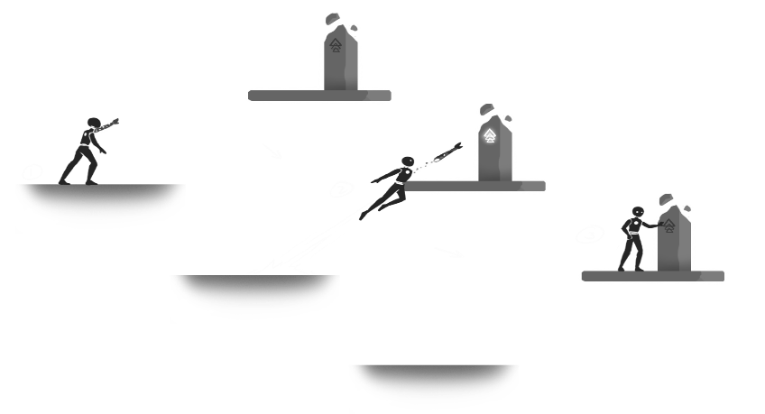

**The Installation**

Click on the following link and download the “Asunder.ZIP” archive from Dropbox:

[INSERT DROPBOX LINK]

After completing the download, right-click the archive and extract the files.

Open the folder “WindowsNoEditor” and double-click “Asunder.exe” to start the game.